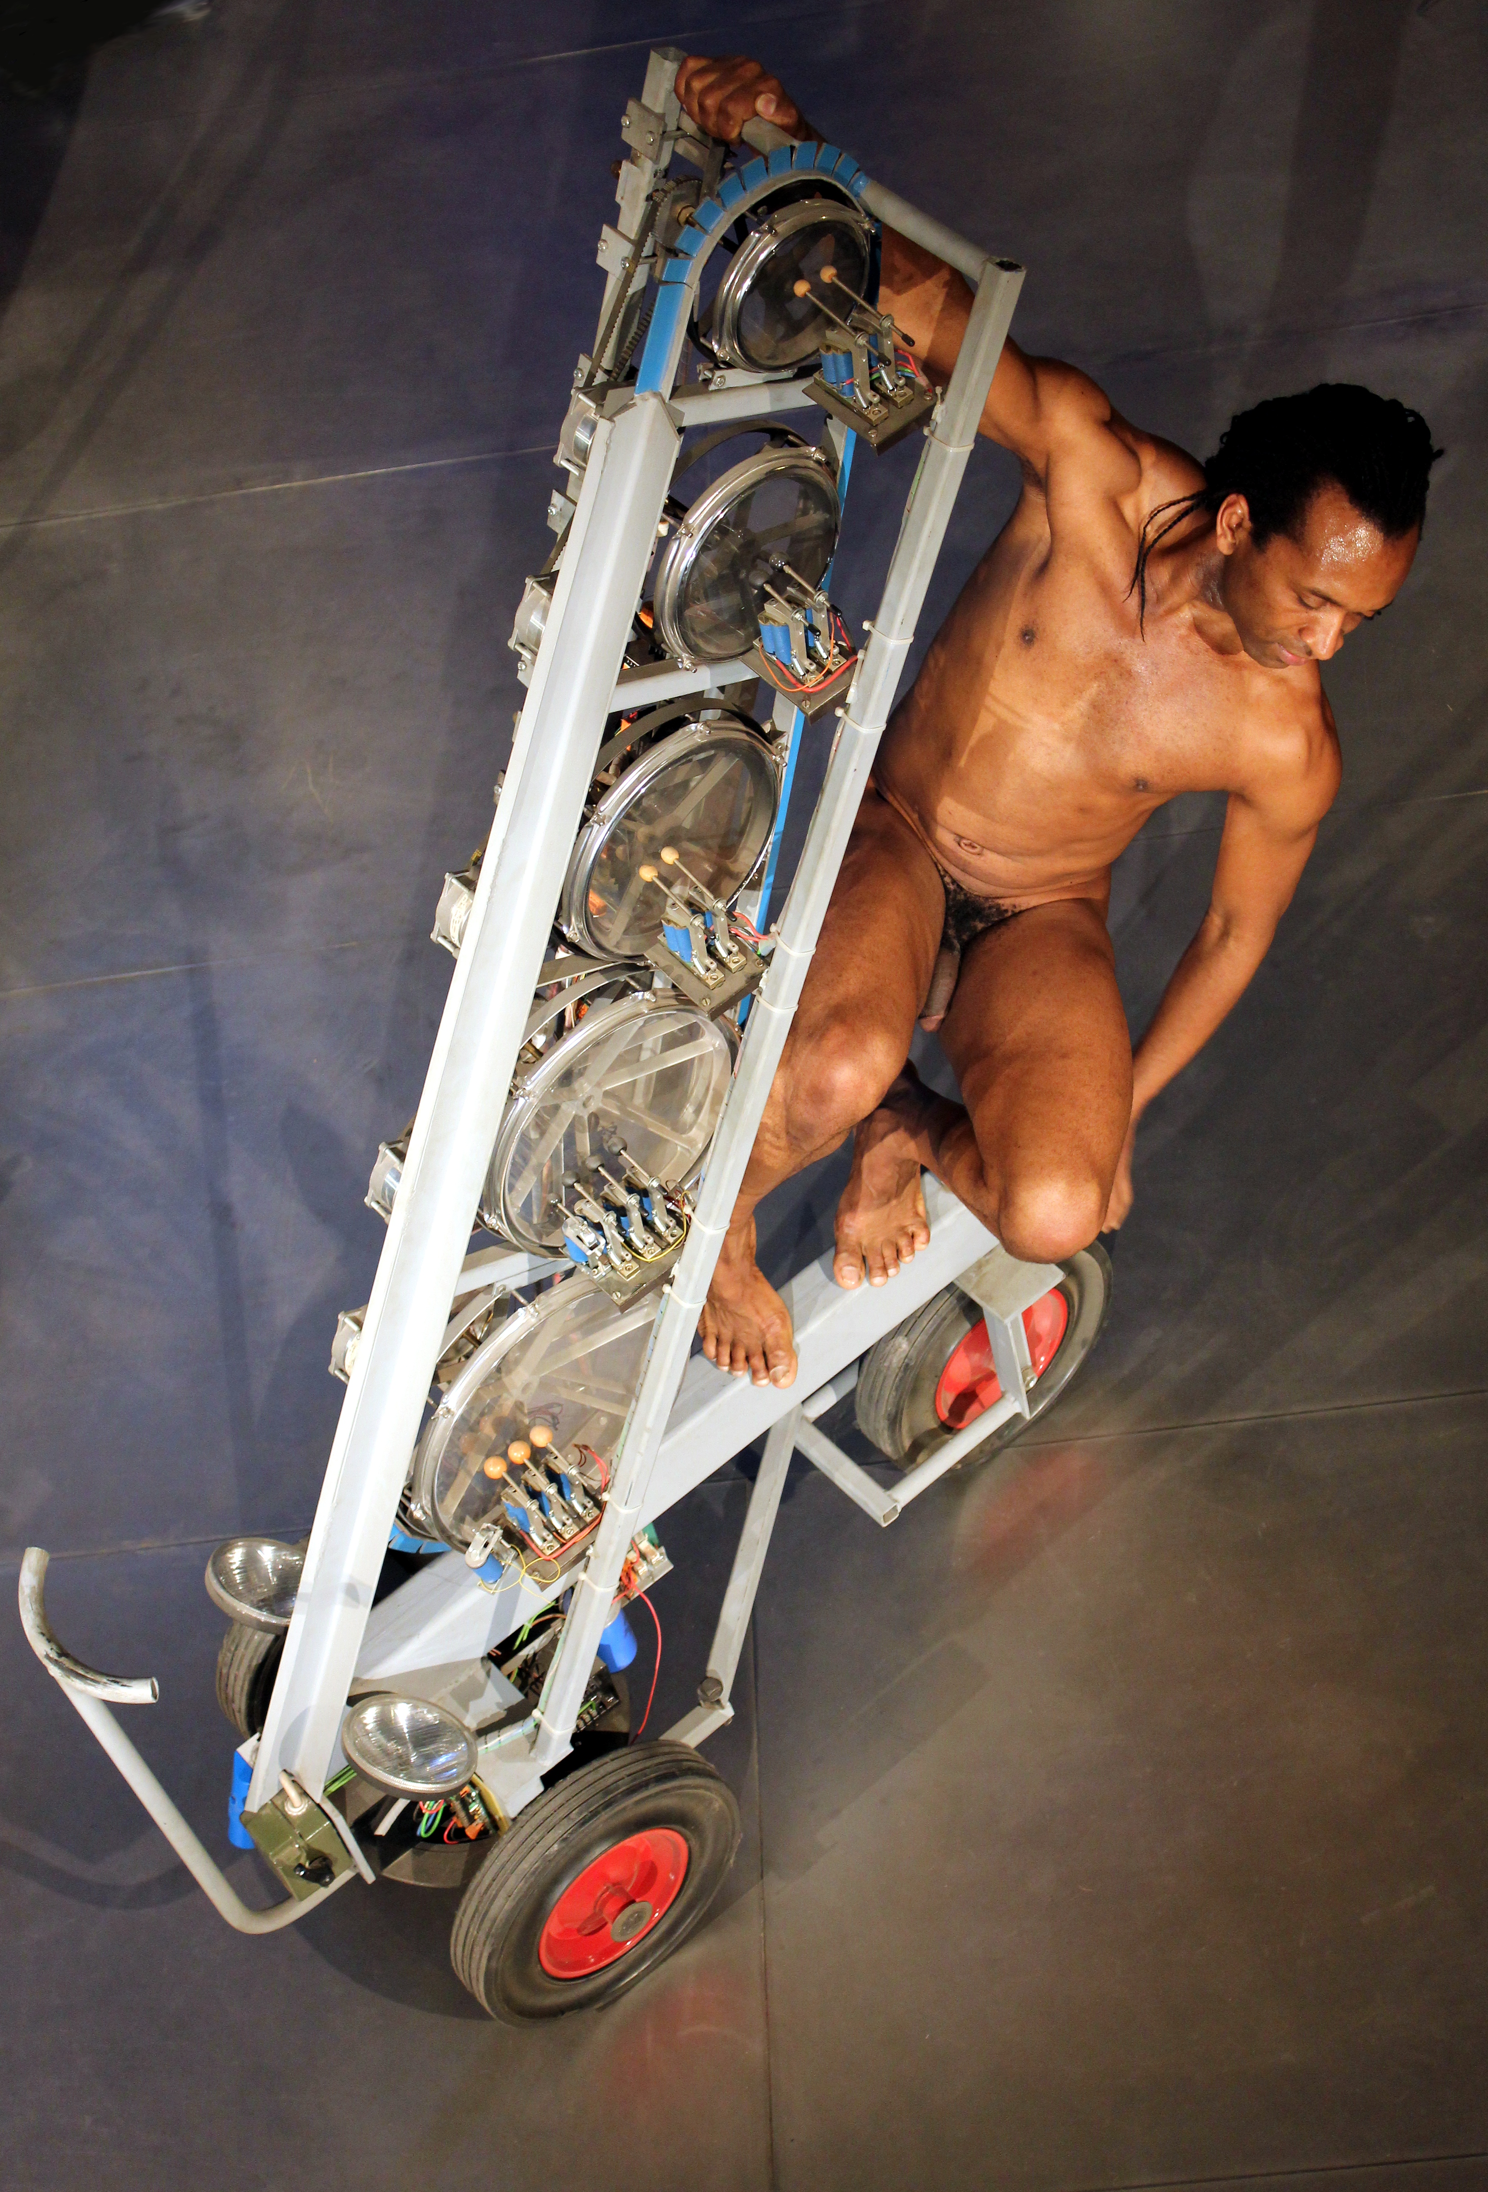

<Rotomoton>
Rototoms are frameless drums that, just because of the lack of a resonator, can be tuned over a range of abouth a fifth. This robot is a computer controlled assembly of five of such rototoms. Each drum is equiped with a set of beaters and the pitch of each rototom can be controlled. The lowest couple of rototoms have 3 beaters each, whereas the upper three suffice with two beaters each. The beaters are velocity sensitive and have a wide range dynamic control. Heavy duty stepping motors are used to achieve pitch control of each individual drum. Instead of rotating the drums on their fixed axis, we fixed the frames of the drums and rotate the threaded axis through a geared construction using dented belts. This also contributes to more silent operation of the mechanics.
The instrument listens to midi data, however, good control of the pitches requires a lot of midi controllers to be send to the robot.
The original version dating from 2000 used hardware based on a parallel bus controlling Intel 16 bit timer chips with a resolution of a single microsecond, next to motor controllers of our own design. It was not directly controlable using midi but required a separate laptop computer to translate midi (or midi via UDP/IP) commands to the parallel bus commands required. In 2005/2007 we redesigned the hardware such that we could get rid of the laptop. No less than 7 PIC microcontrollers now take care of the control of every detail of the mechanics. The timing resolution suffered a bit under this change and is now limited to 19.2 microseconds.
The stepping motors use special circuitry, and make use of motor controller hybrid power modules. Since in this application, very high force but no holding torque is required from the steppers, we could use many power saving features available from these motor controllers.
Two inputs on each microcontroller for the steppers are used to read the start and end position of the tending mechanism, two bytes for each drum. Inductive proximity sensors with 0.01mm resolution were used to this purpose. Herewith we could obtain a hysteris of ca. 30µm. For precize positioning, it is mandatory to reset all motors first to the lowest and next to the highest end position prior to running music compositions. This calibrates the pitch range for each drum. Software to handle this automatically has been integrated into our <GMT> programming language.
As other instruments belonging to this percussion project (a complete range of robotic percussion instruments), this one also is designed for mobile use and thus mounted on sturdy steerable wheels.

