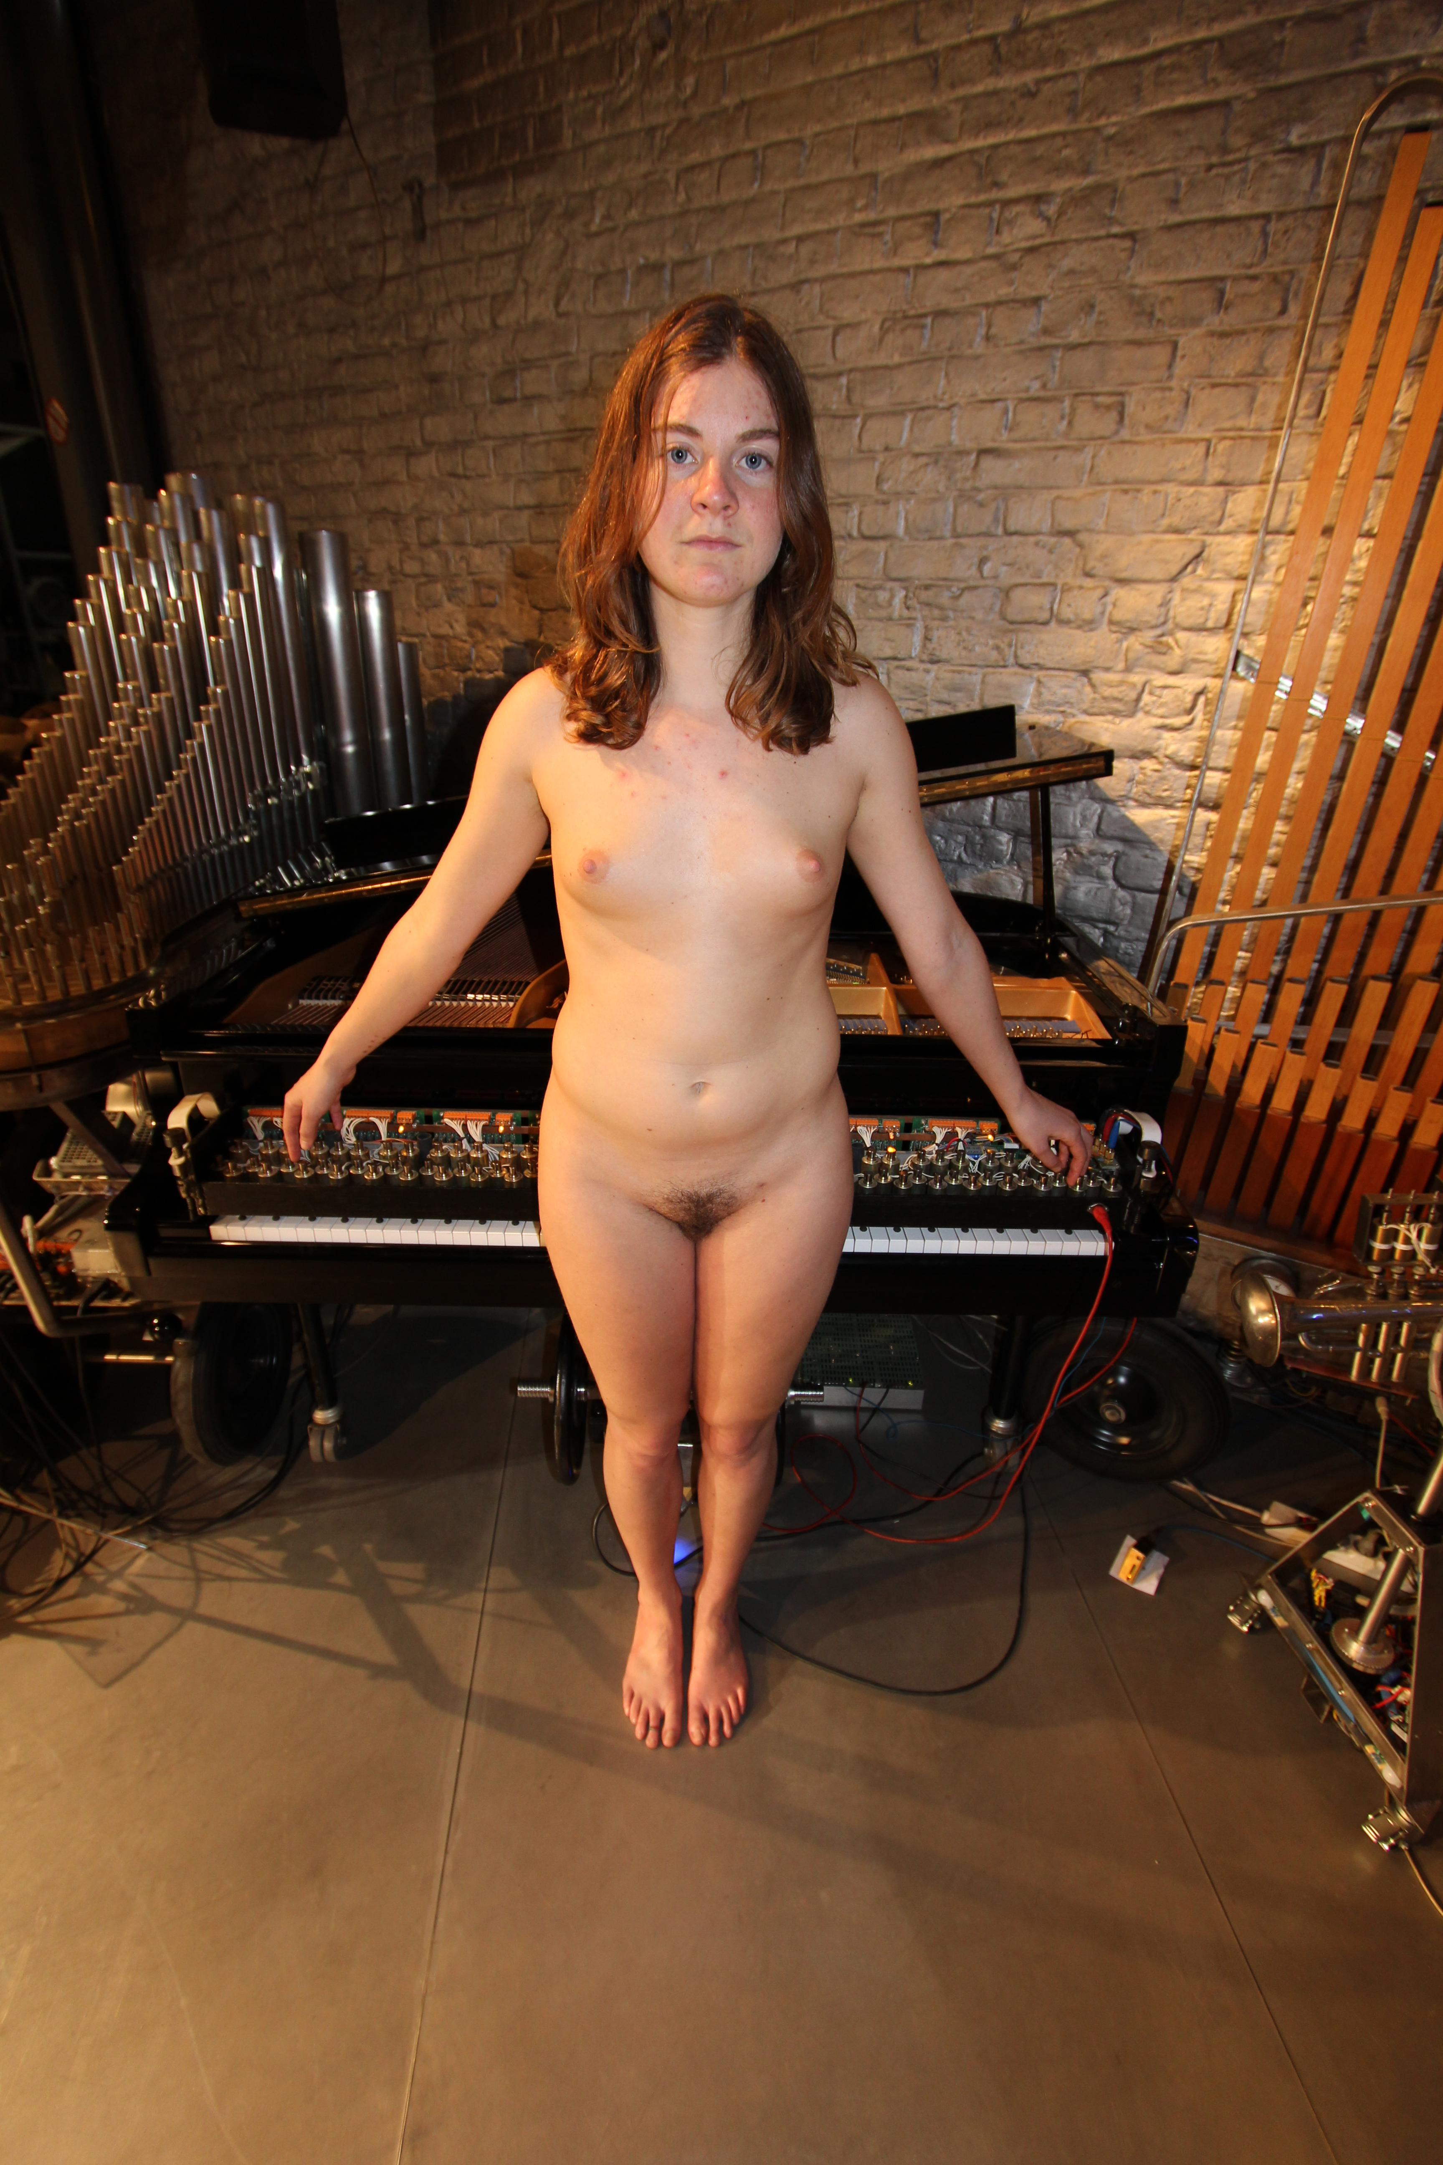
<Player Piano>
The player piano is one of the oldest musical robots build and developed at the Logos Foundation. We spent many years of research into automating pianos. Our designs started with the already very elaborate design by our friend and colleague Trimpin, who worked on his design whilst in Holland at the conservatory with Floris Van Manen. Improvements we realized in our first design are mostly related to sturdiness and reliability. In 2004 we started the design and construction of a completely new type of piano Vorsetzer (Player Piano II) , of course building further on the experience gained in the first designs. The new model makes use of 9 PIC microcontrollers, one controller for every group of 10 piano keys. It has an even better dynamic resolution and can be adapted via uploadable lookup tables to many different types of grand pianos. Because of the very fast PIC controllers, polyphony and timing precision is even better than in the previous design, although that also was 88-note polyphonic, but suffered a bit from the serial design bottleneck problem. The only element limiting polyphony in the new design is the capacity of the power supply. A full fff cluster on all keys together requires some 150 Amps of current... The newly designed player piano was finished in July 2005 and baptized <pp2>. In 2006 we improved the PCB's for player pianos by increasing the density. A single board of the new type can take care of 14 notes. So for a complete piano, only 7 boards are required. These boards use a Microchip PIC type 18F4620. Assembled boards with programmed PIC's for player piano are available from the Logos Foundation. The special rubber feet required to fit on the anchors of the solenoids and designed by us in 2006 are available as well. In 2014, a new board as well as new firmware -covering an octave- was designed. These boards are quite a bit cheaper in production.
In 2016 some major improvements were implemented: automated note repetition and fully controllable holding force and velocity scalings. Also the piano pedal has undergone a major revision. Full technical details are available on our website.
Musical range:

In the latest model, <pp2>, the key controlling electronics could find a place in and on the Vorsetzer chassis itself. Only the hefty power supply remain in a separate 19” enclosure to be placed under the piano. Therefore, the mechanism is slightly heavier than the first model.

