Synthesizers

In many respects, analog synthesizers can be considered as a specialized form of an analog computer. As a matter of fact, electronic synthesizers -unrelated to music- are in the first place analog computers used to synthesize arbitrary waveforms. They were and still are used in radio technology, astronomy, radar equipment and ballistic weaponry.
Basically analog computers just like music synthesizers consist of only three basic electronic components or subsystems: operational amplifiers (used for integration, differentiation, summing, subtracting...), multipliers and exponential or other non-linear functions. As far as their musical applications are concerned, we treated the multipliers in our chapter on ring modulators. They are in fact technically identical. Operational amplifiers are very fundamental components in all analog electronic circuitry and there is plenty of literature available on them. The basics are actually pretty simple and not a lot of math is required to get them to work for you. Readers will notice that we encountered them already in our chapters on tape recorders, preamplifier's, contact microphones etc...
Thus the only very specific issue we have to deal with here has to do with the logarithmic nature of our hearing apparatus. Both our hearing of loudness levels as our perception of pitch are fundamentally logarithmic. Hence the need for circuits with similar logarithmic characteristics if we want to design and use electronic synthesizers as musical instruments.
In the first generations of music synthesizers, the required log characteristic was often obtained by using components such as logarithmic potentiometers for volume and pitch control. With the advent of voltage controlled music synthesizers, that made forms of 'programming' possible, (since the late sixties that is), came the need to develop standards for steering the components. The universal standard here became the 1V/octave norm. Thus for a pitch span of 10 octaves, a control range of 0 to 10 Volts reached out. However, within every octave step op 1V, the curve had to be strictly logarithmic as well and so 'equal temperament' was required and implemented according to the twelfth root of two increments for chromatic steps. Achieving this was always a challenge to engineers and designers as the degree of precision required was very high leading to expensive components, precise temperature control, precision capacitors and resistors...
The first generations of synthesizers were modules without keyboards. They used patch cords and/or matrices for programming. Popular machines were the EMS VCCS3 ('Putney'), the MiniMOOG, the Korg, ARP, Buchla, Serge instruments.
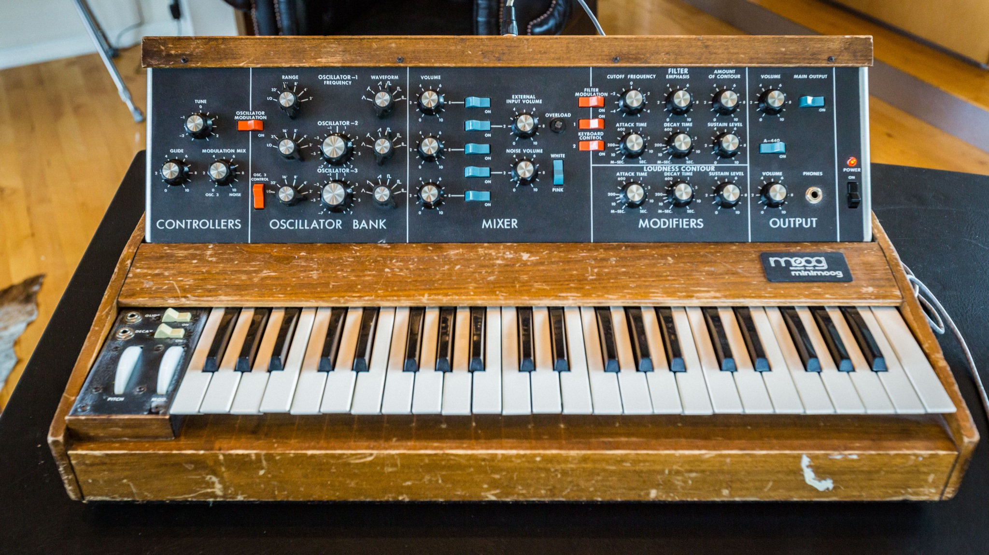
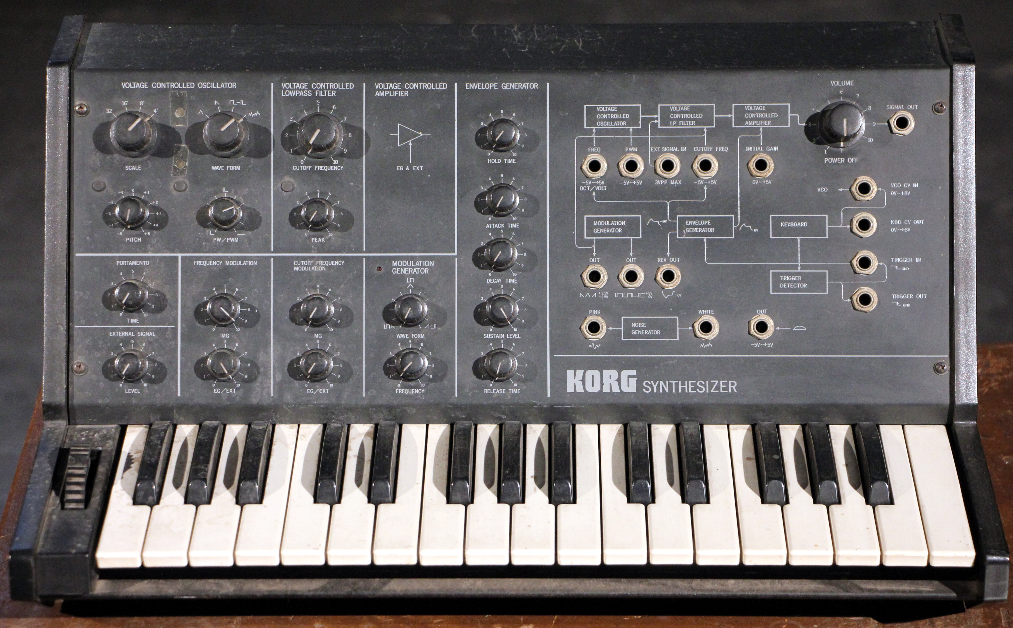
Keyboard synthesizers were introduced in the seventies and caused their widespread use in pop- and commercial musics. The first types -such as the Korg model shown on the picture above- were monophonic. In the early eighties, MIDI-control became the universal way for controlling synthesizers and with it, the synthesizers turned into pure digital machines. By the end of the millenium, there hardware started to vanish as the gradually were replaced with pure software based implementations.

The term 'patch', still in general usage, is a leftover from the epoch that actual wires with jcks on both ends were used.
On the picture below, the Australian/American composer Warren Burt working on an old synthesizer:

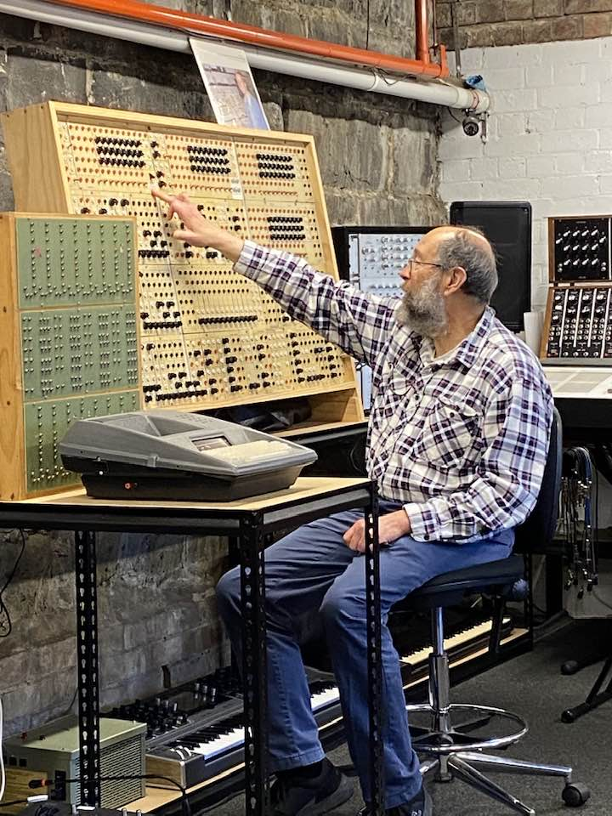

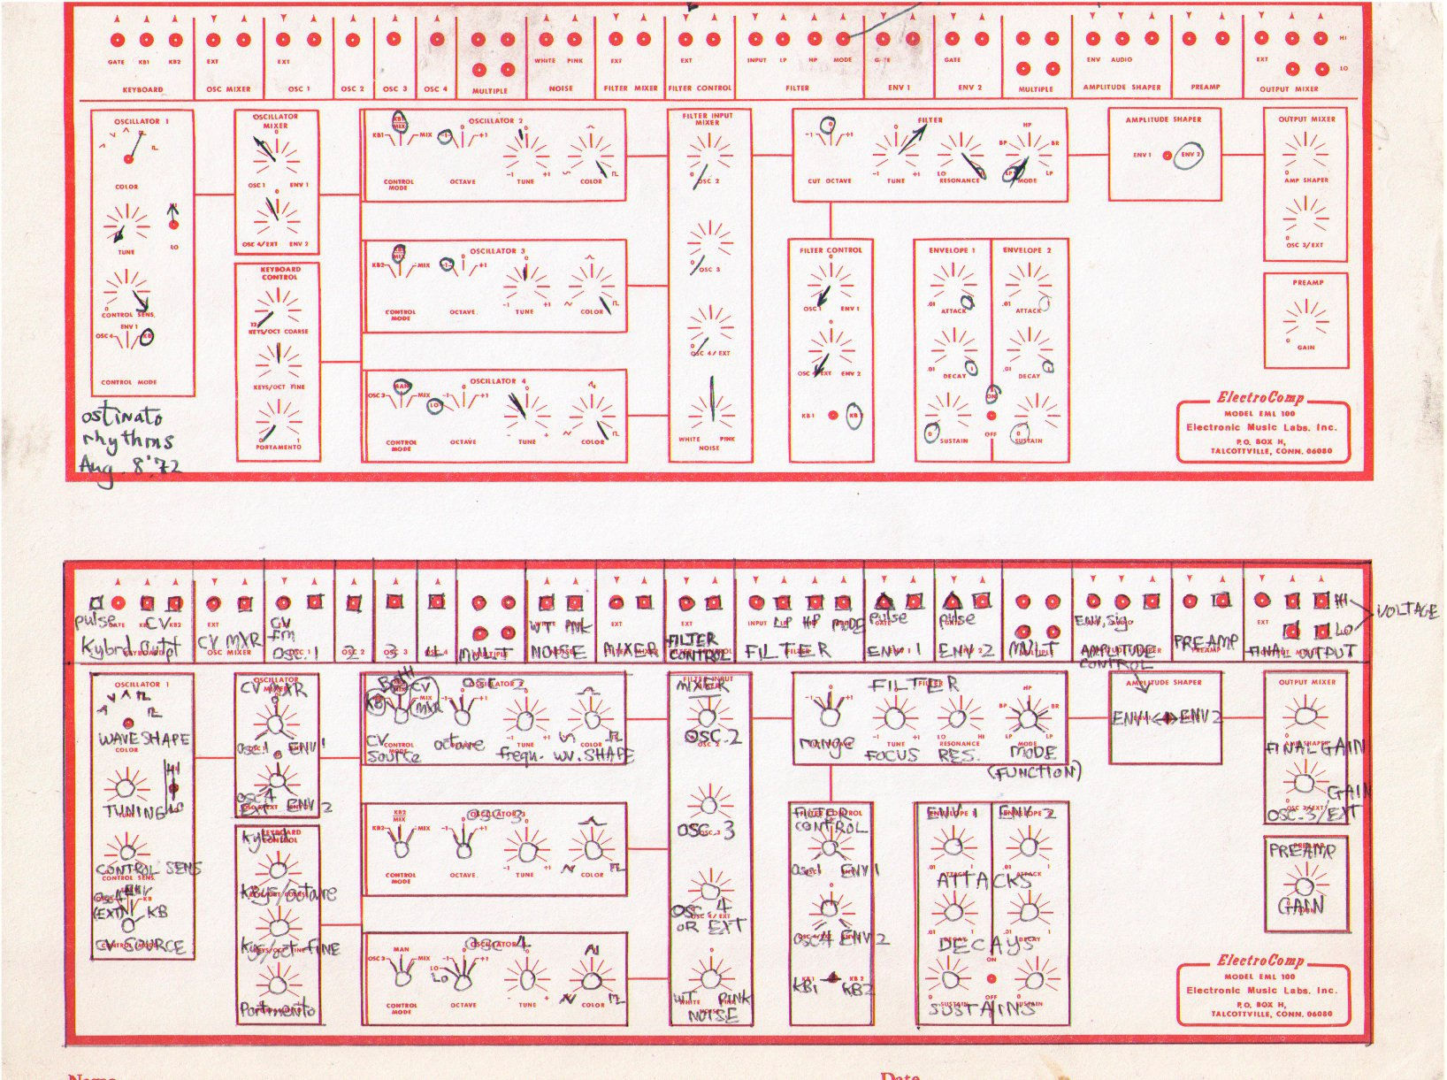
Music using synthesizers in general used 'patch-sheets' as score material. These sheets are extremely machine specific and -if the original machine is no longer available- rarely reproducible or translatable to another machine.

